IRS Data Exchange Bulk Upload Instructions

Some forms now have the Bulk Upload utility built into them, such that data for a form can be added to a spreadsheet template, then uploaded into the IRS Data Exchange (IDEx), instead of having to manually enter the data into the form.

The forms now utilizing the Bulk Upload capability are:
- Graduation
- CTEA 1A
- CTEA 1B
- CTEA 2A
- CTEA 2B

If a form has Bulk Upload capability, the following options will appear at the beginning of the form:

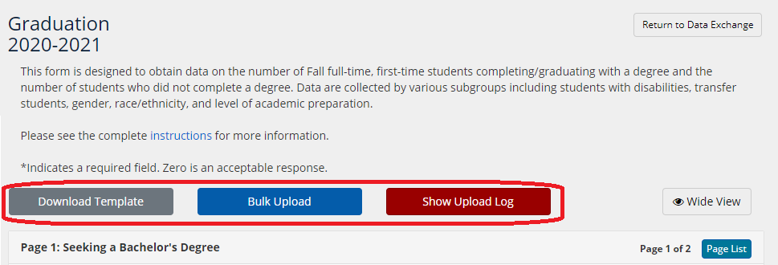

Instructions for using the Bulk Upload utility:

- Download a current copy of the template to populate.
  - Click on the Download Template button.
  - Save this file on your computer (It is recommended to download a new copy of the template each year. Form headings and tab names must be the same as in the latest template).
  - Populate the template according to the HEDS instruction manual and the IDEx form instructions.

- Once file is populated and ready to upload, click on the Bulk Upload button.

- On the next screen, click Choose File, then locate and select the file on your computer to be uploaded.
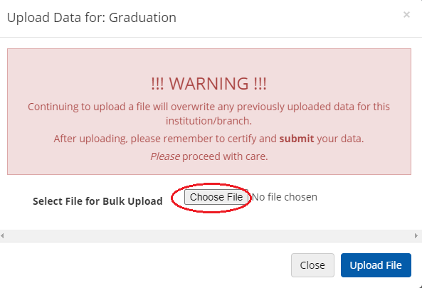

- Once you have selected the file to be uploaded on your computer, click on the Upload File button.
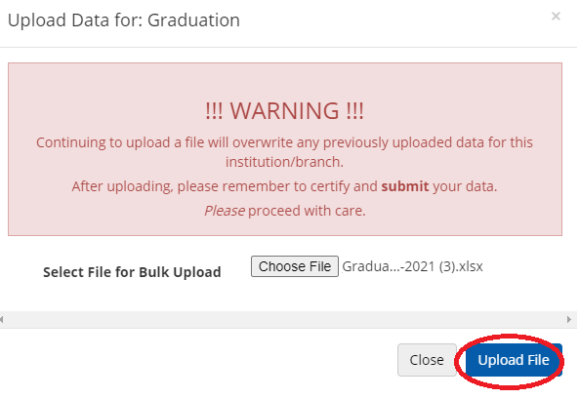
You will see the following screen:

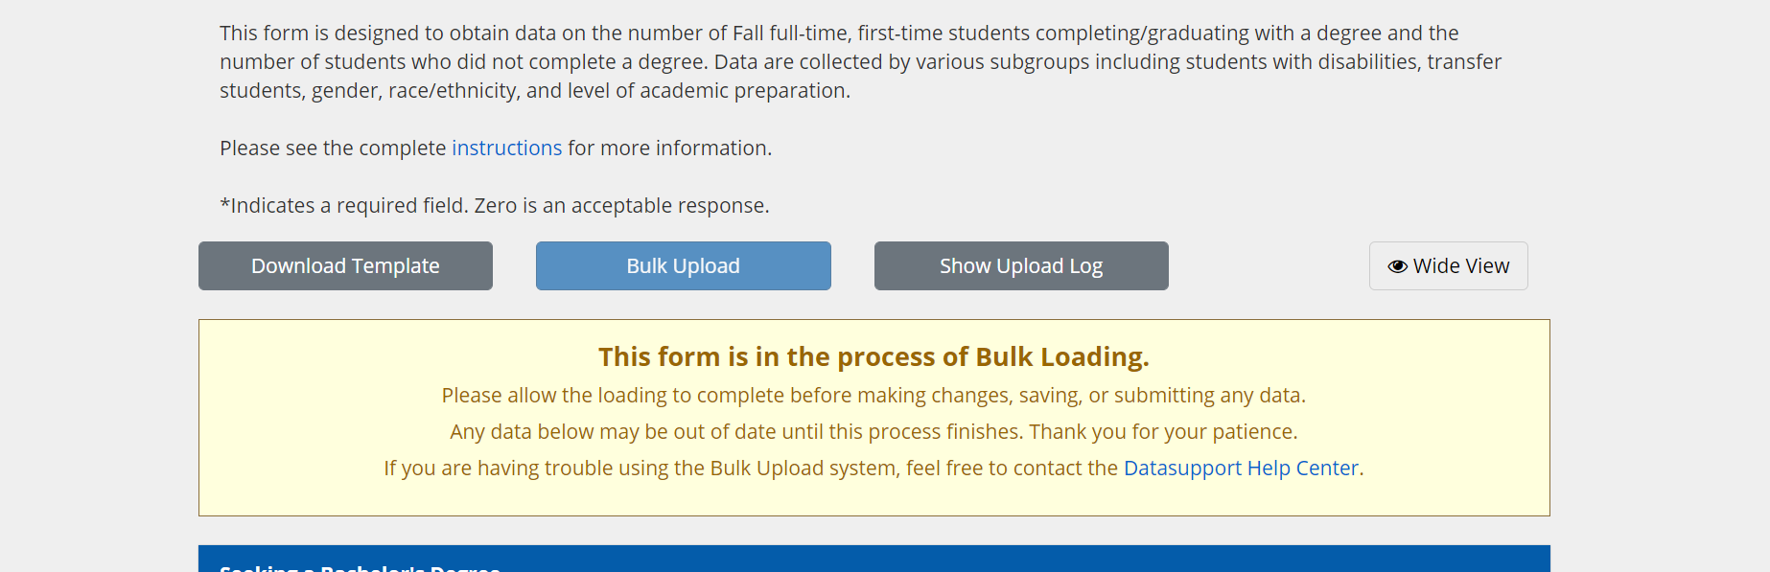

Please allow the loading to complete before making changes, saving, or submitting any data. This process may take a few minutes. By hovering your mouse over the Show Upload Log button, you can see the form’s status; initially, it will say “Validation Started”:

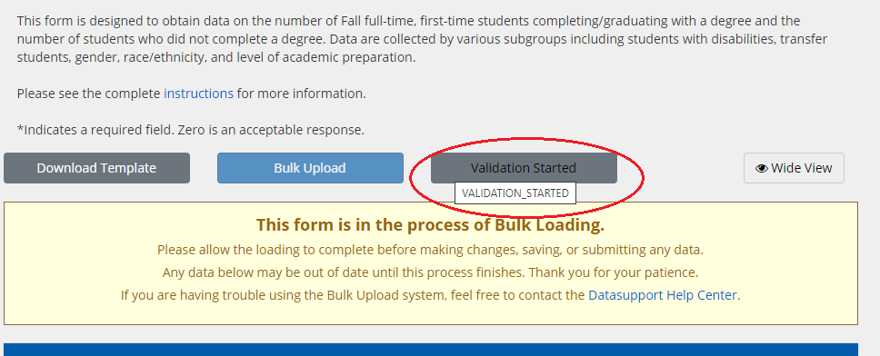

If the file is uploaded successfully, you will see the following:

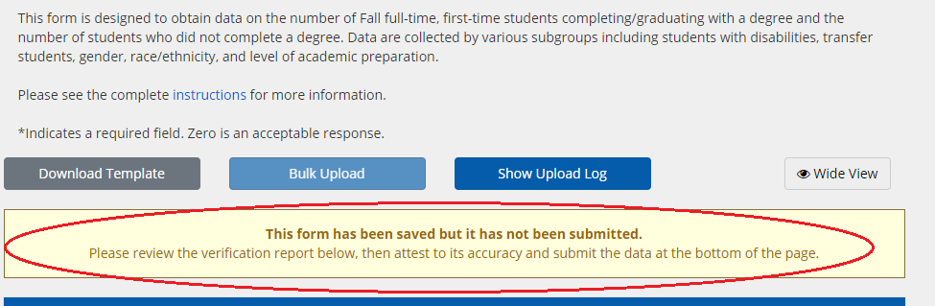

Please note that the form has been saved, but it has not been submitted!

By hovering your mouse over the Show Upload Log button, you will see “1 Form Uploaded”:

If you click on the Show Upload Log button, the Status History log will appear, showing that the Bulk Upload has been successfully completed. However, your submission is not finished until you review, attest, and Submit this uploaded data.

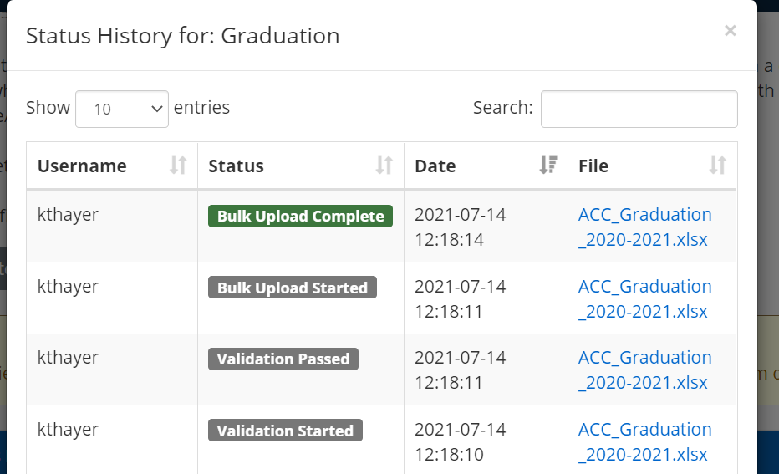

- To complete the data submission, close the Status History log, then scroll to the bottom of the data form. You must check the Attestation box, and then click on the Submit button to complete the submission of the form.

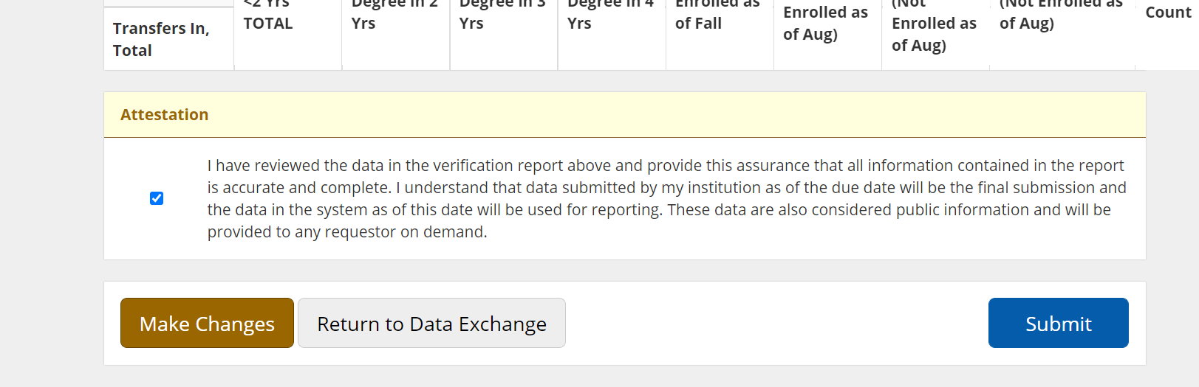

Data will appear in the form, and you will receive a message stating that the form has been successfully submitted:

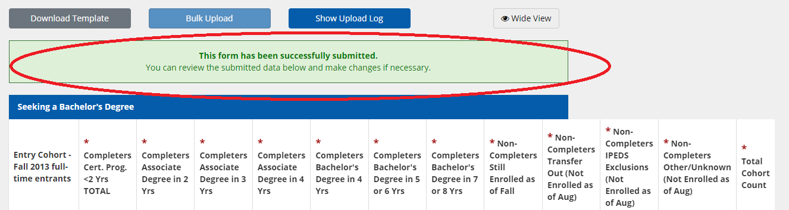

Making Changes / Revising Data

- To make changes to data that has already been submitted, open the desired form, and click on the Make Changes button, located at the top right corner of the form.

Note: If the form’s due date has passed, you must contact IRS Higher Ed Support at higheredsupport.nysed.gov to request that the form be unlocked before being able to Make Changes.

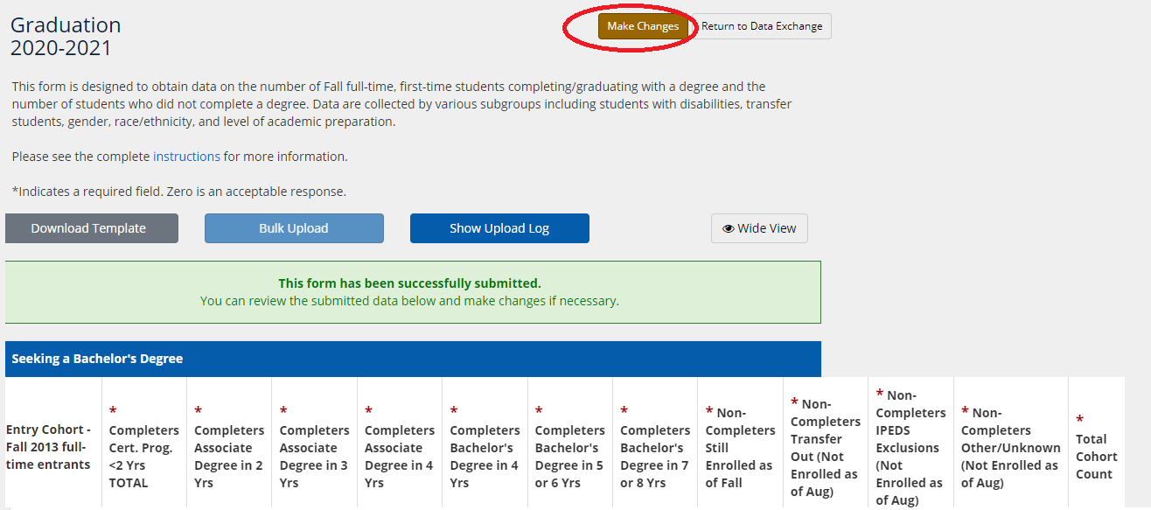

- Repeat the Upload process.

If the file did not upload successfully, the Show Upload Log button will be in red:

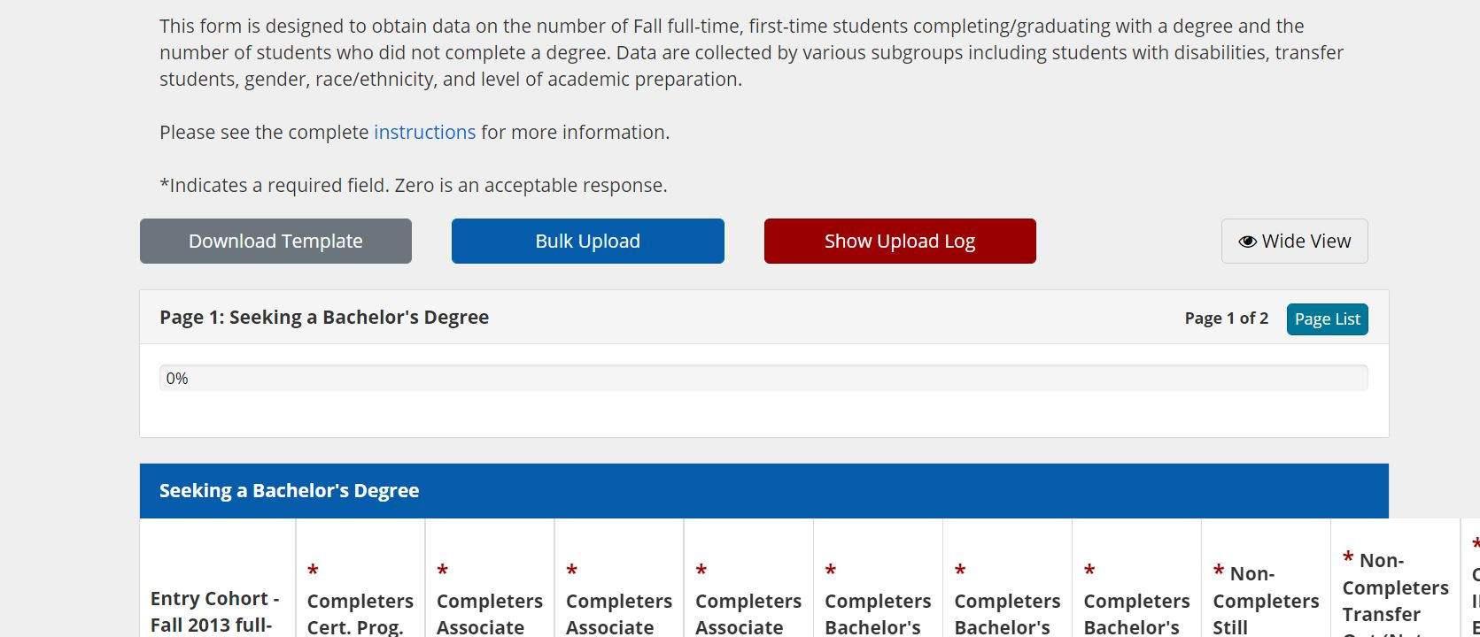

If you hover over the Show Upload Log button, you will see the following message:

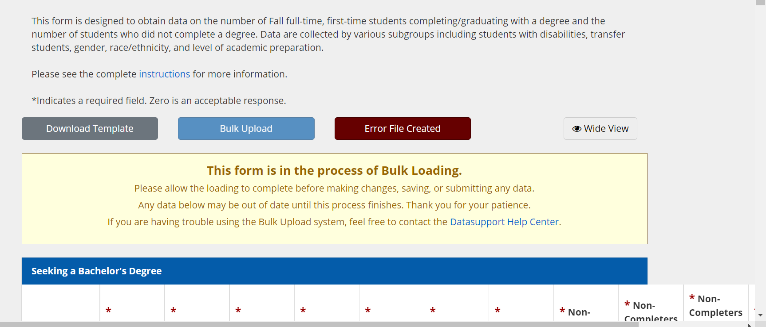
ERROR_FILE_CREATED

If you click on the Show Upload Log button in red, the Status History log will appear, showing that the Bulk Upload was not successfully loaded. An error file is displayed that you can download and open to identify and correct the errors.

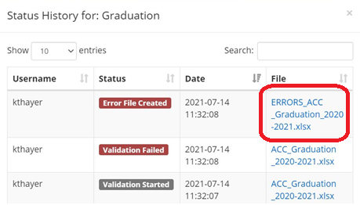

Note: Within this Excel file, there are multiple tabs; the first tab is an Errors Index, outlining all errors contained in the file, and where they occur. Each additional tab corresponds to a single page of that data collection form. Clicking on a specific error will give you more information, and show you where that error is located.

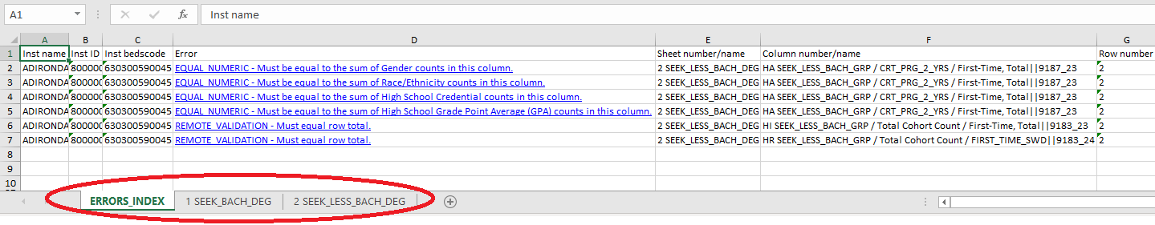
IMPORTANT NOTE: The errors file is to be used as a guide only. When making corrections to your data, please do not do so within this error file. Corrections must be made in the original Upload file. Once you have corrected the original Upload file, retry the Upload process until the file is successfully uploaded. Be sure to complete the submission process, including reviewing, attesting, and submitting the data.

