**CTEA Step-by-Step Instructions to Bulk Upload File**

1. Once logged into the IDEx, click on the form that you are looking to upload.

• First Submission – CTEA 1A and/or CTEA 2A - (Due September 30, 2021)

• Second Submission – CTEA 1B and/or CTEA 2B - (Due February 18, 2022)



1. Click on the “Bulk Upload” button.

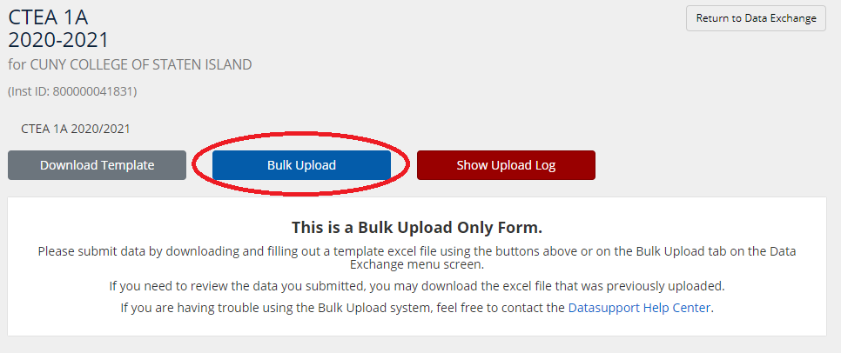

If unable to click on the “Bulk Upload” button, you may have previously uploaded a file. If this is the case, you will need to click on the “Make Changes” button in the upper right of your screen, then click on “Bulk Upload”, to upload a new file.

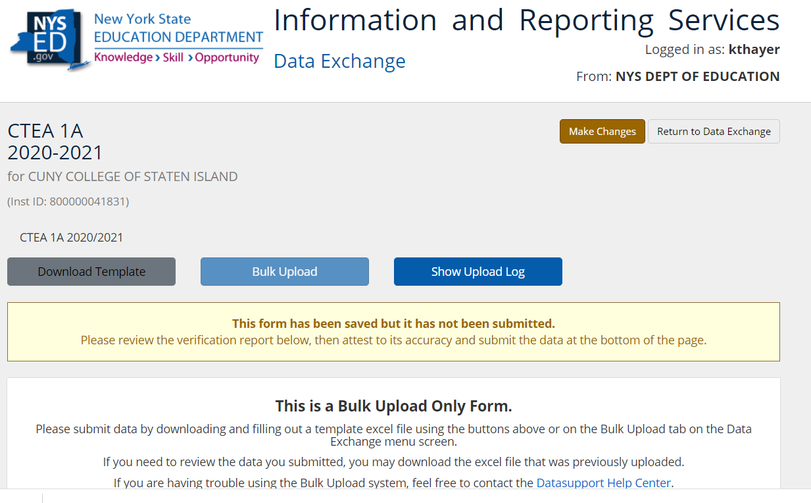

1. Click on “Choose File” and find the file on your computer to upload.

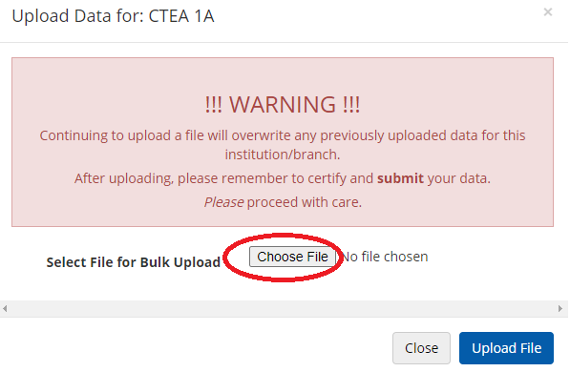

1. Once the file name appears in the box, click “Upload File”. You will see a little circle spinning. It may take a minute to complete because it must first validate the file.

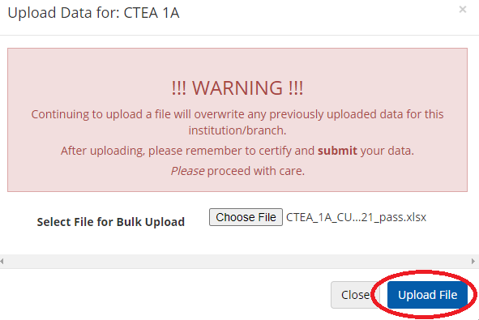

1. If the “Show Upload Log” button is blue, your file has uploaded successfully. If you hover over it, it will display “1 Form Uploaded”.

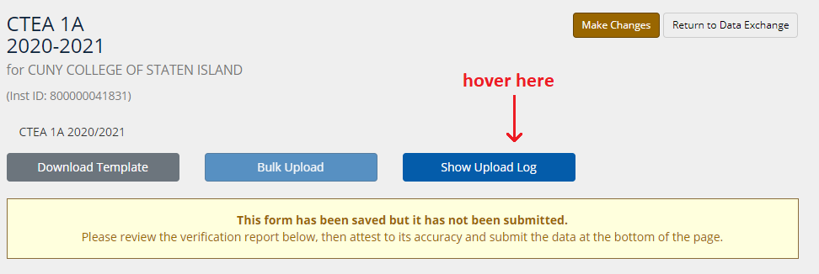

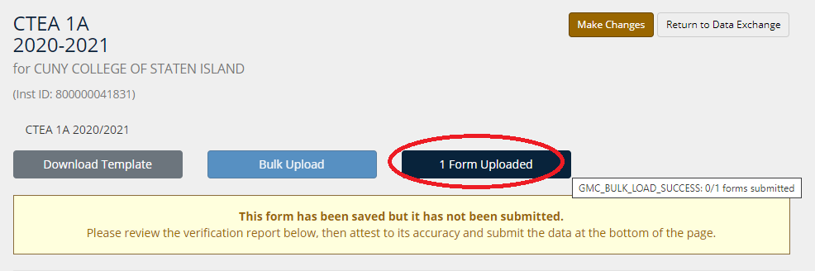

1. If the “Show Upload Log” button is red, your file upload has failed. If you hover over it, it will display “Error File Created”.

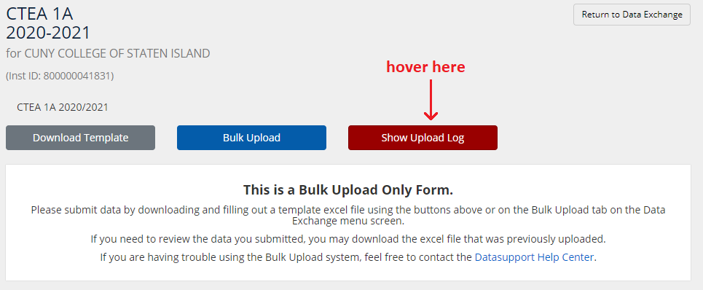

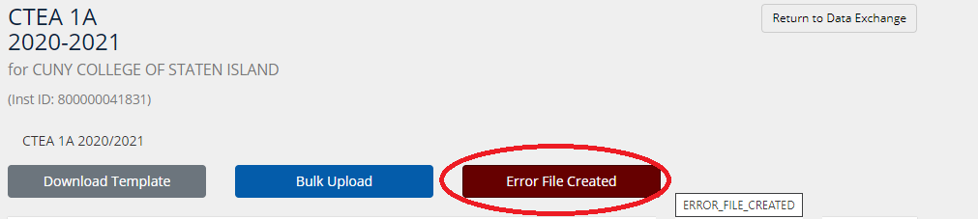

1. If the validation has failed, click on the “Show Upload Log” / “Error File Created” button, and a Status History will appear in the pop-up window. Select the ERRORS Excel file in the File column to view or download the errors.

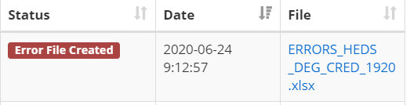

This error file spreadsheet has two tabs; the first displays an index of errors, indicating where they have occurred, while the second tab contains the actual file that was attempted to be uploaded, with the error cells highlighted. (Note: You can click on the error in the first tab [Column D], and it will take you to that error in the second tab.)

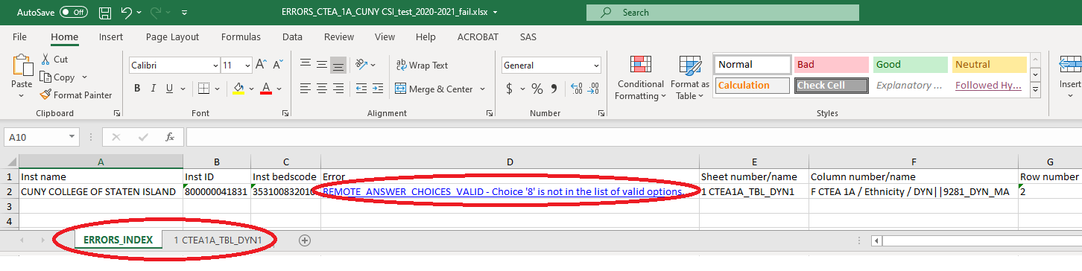

1. Once you have fixed all the errors, and have a corrected file, repeat the Bulk Upload process until upload is successful.
2. Click on the “Show Upload Log” / “1 Form Uploaded” button, and the most recent status should be “Bulk Upload Complete”, in green.

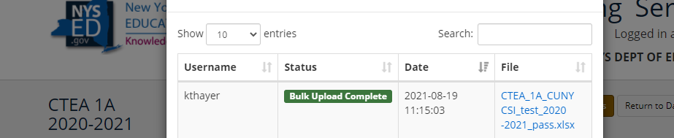

1. Once the file has been successfully uploaded, please note that the report is still in a **SAVED** status. It must be reviewed, attested, and **SUBMITTED** to complete the process. Under the Attestation section, check the box, and then click the “Submit” button.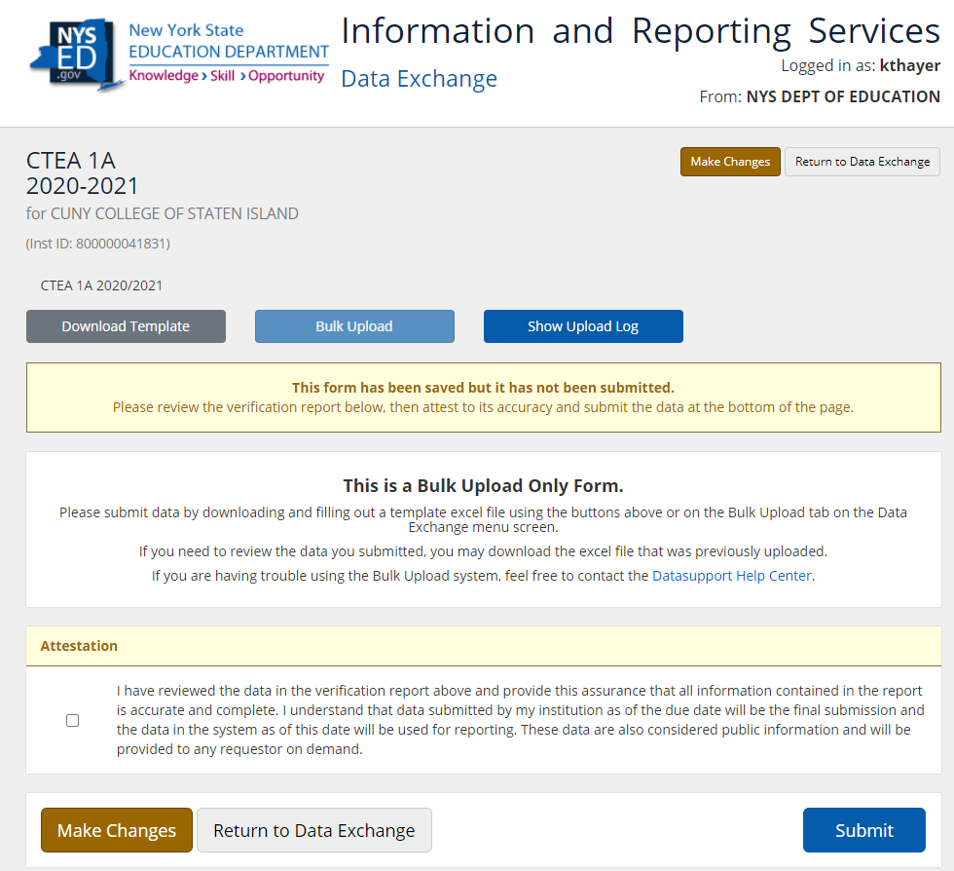
2. From time to time, it is discovered that a mistake was made after a file has been uploaded, reviewed, attested, and submitted. To make changes to a submission when the due date has *not* passed, click on the “Make Changes” button. This will allow you to make changes to your form and start the process over to Bulk Upload your file. Make sure you complete the entire process, from uploading to reviewing, attesting, and submitting your data.

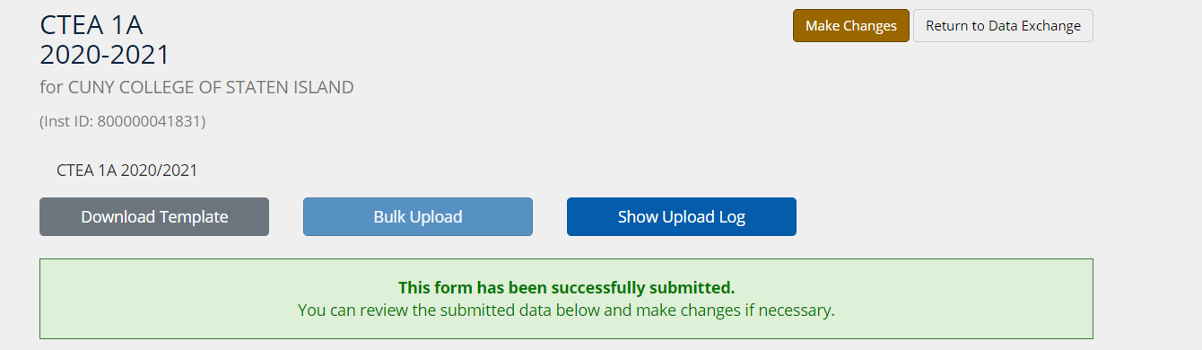

If the due date has passed, you must contact us by sending an e-mail to [higheredsupport@nysed.gov](mailto:higheredsupport@nysed.gov) and ask that we unlock your form so that you may make changes and re-submit your CTEA data.