Downloading the CTEA Templates

- Login to the Application Business Portal at https://portal.nysed.gov/abp

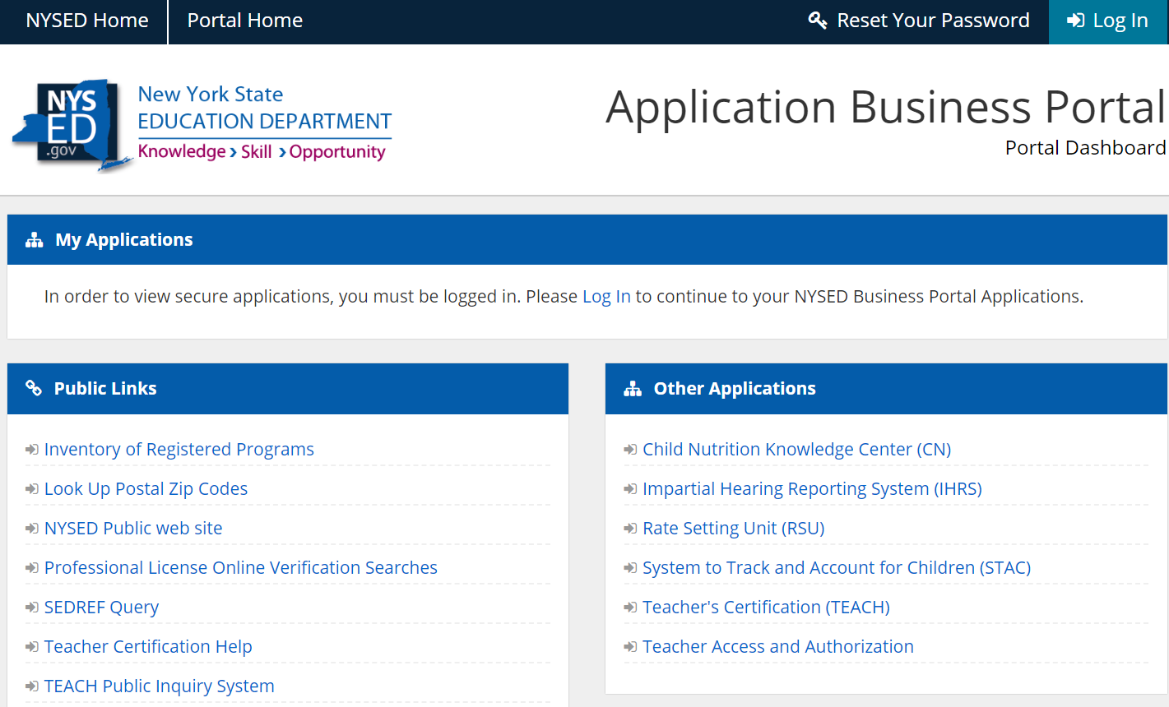

- Select IRS Data Exchange under ‘My Applications’

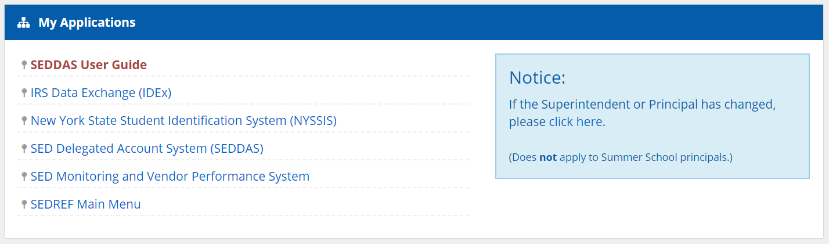

- Select the form you want to download the template for:
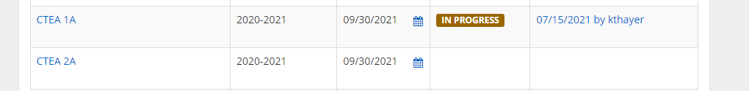

4. Click on Download template.